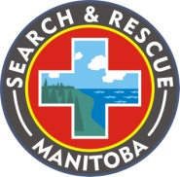
OFFICE OF THE FIRE COMMISSIONER
MANITOBA EMERGENCY SERVICES COLLEGE

SARMAN Volunteer Training Report

Complete and email to: firecomm@gov.mb.ca 2012/13

Tasking #

SUMMARY OF EVENT/ACTIVITY

Location of Event: Hosted by:

Event Description:

Type of Event/Activity: Training: Prevention: Meeting:

SARMAN Teams in Attendance:

________________________________________________________________________

TRAINING EVENT

Navigation:

Survival:

Search Techniques:

Administration/Operations Procedures:

Other:

Please provide a short summary of each area covered:

Documents submitted such as agendas and training notes shall be added to file.
________________________________________________________________________

For Prevention activities or Meetings, list the type of activity under “Other”

ATTENDANCE SHEET
SARMAN MEMBERS TAKING PARTCIPANTS

